Q1. Explain Exception Handling in java programming?

Ans:

When executing java code, different errors can occur, coding errors made by the programmer, errors due to wrong input

When an errors occurs, java will normally stop the program and generate an error message. The technical terms for this, in java will throw an exception.

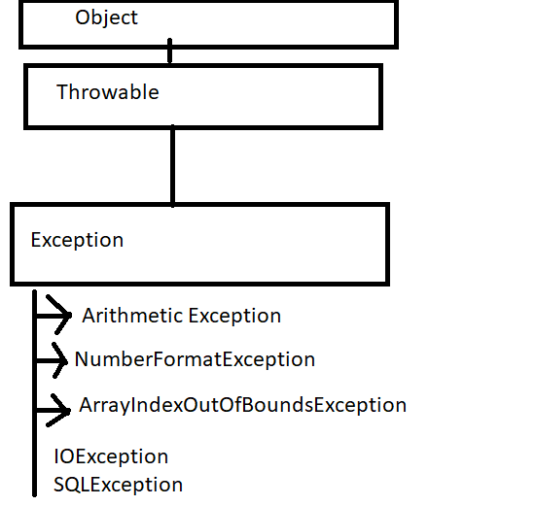

In java programming we use 5 keyword to handle the exception

1. try
2. catch
3. finally
4. throw
5. throws
6. try:

The try statement allows you to define a block of code to be tested for errors while it is being executed .

1. catch:The catch block statement allows you to define a block of code to be executed if an exception occurs in the try block

Catch block is always take an argument Exception class or Its Derived class

A single try bock followed by multiple catch block.

A catch block is conditional , if Exception occurs then catch block will executed.

Inside catch block we write handling code.

Syntax:

try{

//code that result may be exception

}catch(Exception){

//handling code

}

